Epidemiology Across the Indian Ocean
By: Emily Adcock
Overview and Purpose:
The 20th Century was a period of intense globalization. Increased levels of interconnectedness between regions brought people, goods, technology, and culture to new places all around the world. However, this increased level of exchange also amplified the risk of infectious disease transmission. The legacy of imperialism and colonization manifests itself in the underdevelopment of economies and infrastructure in Africa and Asia. Colonial powers expropriated local production, trade, land, and resources in order to industrialize, causing an uneven spread of development. (Ziltener 2016). As a result, many health care systems in the Indian Ocean region are now ill equipped to address growing public health threats.
Meanwhile, those that did industrialize are still vulnerable to health concerns from overcrowding and environmental pollutants. The geography and seasonal monsoons position inhabitants of the Indian Ocean region at greater risk of natural disasters like earthquakes, cyclones, and tsunamis. With climate change, the frequency of these natural disasters is increasing. Natural disasters often lead to disease outbreaks because severe infrastructural damage and flooding cause breakdowns in sanitation services and services that satisfy basic needs such as food, water and shelter.
Infectious diseases are an ever-changing and far-reaching issue with modern implications. Recognizing where they come from is imperative to eradication. Epidemiology is the method used to find the causes of health outcomes and diseases in populations (CDC 2016). Epidemiologists research disease distribution patterns and determinants of health in order to create long-term solutions. Including epidemiology in curriculums of world history and geography is crucial to demonstrating the connection between STEM and social sciences. Teaching epidemiology in the Indian Ocean also provides a more comprehensive understanding of world systems from the 18th century to the present.
Using the Industrial and Imperial Era and 20th Century and Globalization maps from the Indian Ocean in World History (IOWH) website, students will learn about different diseases in the Indian Ocean Region such as Scurvy, SARS, Chikungunya and Cholera. They will also identify and discuss the underlying causes of these diseases; including globalization, industrialization, underdevelopment, imperialism, and the environment. Lastly, the lesson plan includes a case study of the International Federation of Red Cross and Red Crescent Societies (IFRC), one of the largest NGOs in the world, to discuss the role of international humanitarian aid as it relates to public health in the Indian Ocean.
Intended Age Group:
AP World History, AP Human Geography

Learning Objectives:
- Learn about different infectious diseases in the Indian Ocean region and identify their underlying causes.
- Expand understanding of the spread of disease to include human and environmental forces, and how they work together.
- Be challenged to think critically about the role of international humanitarian aid and its impact on public health in the Indian Ocean region.
Time:
This lesson should take 3 class periods of 50 minutes each.
Materials Needed:
X = number of students
- Independent or partnered access to computers or tablets
- Projector
- Handout 1: Background
  - X copies of Reading 1.1: Industrial and Imperial Era, “Historical Overview”
  - X copies of Reading 1.2: Twentieth Century to the Present, “Historical Overview”
- Handout 2: Research
  - X/4 copies of Handout 2.1: Scurvy
  - X/4 copies of Handout 2.2: SARS
  - X/4 copies of Handout 2.3: Chikungunya
  - X/4 copies of Handout 2.4: Cholera
- X copies of Handout 3: Humanitarian Aid
- 1 copy of Handout 4: Sample Discussion Questions
Procedure:
Day 1
- (5 mins) Project or distribute copies of the learning objectives outlined above. Together take turns reading and discussing the objectives to familiarize the class with the lesson.
- (20 mins) Distribute Reading 1.1-1.2 and read together in class. When you have finished, have a group brainstorming session about the key takeaways. The sections in these readings (industrialization, climate change, imperialism, underdevelopment, globalization, etc.) will be the framework for understanding the cause of the diseases discussed in the rest of the lesson.
- (25 mins) Divide students into 4 groups (Scurvy, SARS, Chikungunya and Cholera) and distribute Handout 2.1-2.4. Students will research their respective diseases independently using the provided resources and complete the handout in the remainder of the class period. Unfinished handouts should be completed for homework.
Day 2
- (45 mins) Have students sit in their groups. Explain that together they will be creating presentations on their designated disease. Reading 1.1-1.2 and Handout 2.1-2.4 will be used to guide them as they prepare their presentations. By the end of the class period, their presentations should be complete. Feel free to walk around the room checking progress and answering questions. Additional guidelines include:
  - One presentation per group.
  - Each presentation should be ~5 mins long.
  - All members of the group should have equal speaking time.
- (5 mins) Distribute Handout 3 and assign for homework.
Day 3
- (5 mins) Check in with all the groups to make sure they have practiced presenting at least once. If not, use this time to finish.
- (20 mins) Each group will present and answer questions from their classmates for 5 minutes. For participation, require one question from each student.
- (25) Arrange the desks/chairs in a circle in the center of the room for a class discussion and wrap-up. Cut small pieces of paper and ask students to write one discussion question for the class about the lesson. Collect the questions and put them in a bowl/container. Take turns drawing questions and reading to the group. Another option is to use the sample discussion questions on Handout 4.

Appendix
- Handout 2.1: Scurvy pg. 5
- Handout 2.2: SARS pg. 6
- Handout 2.3: Chikungunya pg. 7
- Handout 2.4: Cholera pg. 8
- Handout 3: Humanitarian Aid pg. 9
- Handout 4: Sample Discussion Questions pg.11
- Bibliography pg. 12

Handout 2.1: Scurvy
Name: __________ Date: __________ Period: __________
Use the following resources to answer the questions:
- http://www.indianoceanhistory.org/LessonPlan/FirstGlobalEra.aspx; read the technologies icon Citrus Juice and Scurvy located in the bottom left corner.
- https://www.bbc.com/news/health-35380716
Question | Answer
What do you know about the virus (symptoms, transmission, treatment, etc.)?
Who does it affect/where is it active?
When did the largest outbreak happen? Was there any reason associated with this outbreak? Why was it worse than previous outbreaks?
How did it spread? Why?
What are the underlying causes? Circle all that apply and explain. | - Globalization  - Industrialization  - Underdevelopment  - Imperialism  - Environment
Handout 2.2: SARS
Name: __________ Date: __________ Period: __________
Use the following resources to answer the questions:
- https://www.who.int/diseasecontrol_emergencies/guidelines/CD_Disasters_26_06.pdf; read the Introduction and Sections 1.2-1.4
- http://www.indianoceanhistory.org/LessonPlan/20thCenturyandGlobalization.aspx; read the geography icon SARS located in the upper right corner.
- https://www.bbc.com/news/world-asia-china-21680682
Question | Answer
What do you know about the virus (symptoms, transmission, treatment, etc.)?
Who does it affect/where is it active?
When did the largest outbreak happen? Was there any reason associated with this outbreak? Why was it worse than previous outbreaks?
How did it spread? Circle the section from resource 1 that best fits and explain. | - Waterborne diseases  - Communicable diseases associated with crowding  - Vector-borne diseases
What are the underlying causes? Circle all that apply and explain. | - Globalization  - Industrialization  - Underdevelopment  - Imperialism  - Environment
Handout 2.3: Chikungunya
Name: __________ Date: __________ Period: __________
Use the following resources to answer the questions:
- https://www.who.int/diseasecontrol_emergencies/guidelines/CD_Disasters_26_06.pdf; read the Introduction and Sections 1.2-1.4
- http://www.indianoceanhistory.org/LessonPlan/20thCenturyandGlobalization.aspx and read the geography icon Chikungunya located east of Madagascar.
- http://news.bbc.co.uk/2/hi/health/5338194.stm
Question | Answer
What do you know about the virus (symptoms, transmission, treatment, etc.)?
Who does it affect/where is it active?
When did the largest outbreak happen? Was there any reason associated with this outbreak? Why was it worse than previous outbreaks?
How did it spread? Circle the section from resource 1 that best fits and explain. | - Waterborne diseases  - Communicable diseases associated with crowding  - Vector-borne diseases
What are the underlying causes? Circle all that apply. | - Globalization  - Industrialization  - Underdevelopment  - Imperialism  - Environment
Handout 2.4: Cholera
Name: __________ Date: __________ Period: __________
Use the following resources to answer the questions:
- https://www.who.int/diseasecontrol_emergencies/guidelines/CD_Disasters_26_06.pdf; read the Introduction and Sections 1.2-1.4
- http://www.indianoceanhistory.org/LessonPlan/IndustrialandImperialEra.aspx; read the places icon Batavia (Jakarta) located near the westernmost coast of Indonesia.
- https://www.unicef.org/yemen/YEM_factsheet_cholera.pdf
Question | Answer
What do you know about the virus (symptoms, transmission, treatment, etc.)?
Who does it affect/where is it active?
When did the largest outbreak happen? Was there any reason associated with this outbreak? Why was it worse than previous outbreaks?
How did it spread? Circle the section from resource 1 that best fits and explain. | - Waterborne diseases  - Communicable diseases associated with crowding  - Vector-borne diseases
What are the underlying causes? Circle all that apply. | - Globalization  - Industrialization  - Underdevelopment  - Imperialism  - Environment
Handout 3: Humanitarian Aid
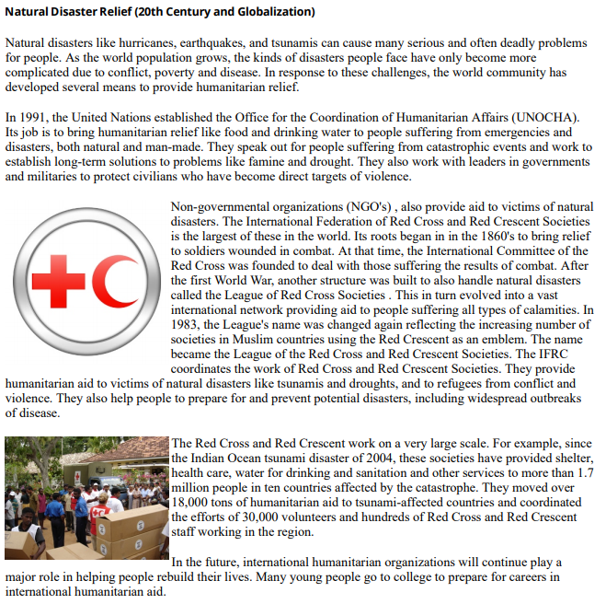
Name: __________ Date: __________ Period: __________
Source: http://www.indianoceanhistory.org/LessonPlan/PreHistoricEra.aspx?keywords=natural%20disaster%20relief

Answer the questions on the next page.

Handout 3: Humanitarian Aid
- Create a pros and cons list of humanitarian aid as it relates to public health.

- Why is there a need for NGOs and international aid organizations to intervene when there is a public health emergency?

- What prevents Indian Ocean countries from independently providing the resources and services needed to address a public health emergency?

Handout 4: Sample Discussion Questions
- How are these diseases similar? How are they different?
- How are the underlying causes connected to each other?
- What was the international response to these disease outbreaks?
- Ask students to share ideas from question 1 on Handout 3. Discuss.
- What do you think the role of humanitarian intervention is in relation to public health in the Indian Ocean? Is it sustainable?
- Has this lesson plan changed your perception of processes like globalization and industrialization? If so, how?

Bibliography
“Communicable Diseases Following Natural Disasters.” Disease Control in Humanitarian Emergencies, World Health Organization, 2006.
“Fact Sheet: What You Need to Know about Cholera in Yemen.” Resources and Documents, UNICEF Yemen, 2017.
Hunt, Katie. “Sars Legacy Still Felt in Hong Kong, 10 Years On.” Asia, BBC News, 20 Mar. 2013.
“Is Scurvy Making a Comeback?” Health, BBC News, 22 Jan. 2016.
“Warning over Tropical Virus Risk.” Health, BBC News, 13 Sept. 2006.
“What Is Epidemiology?” Teacher Roadmap, Centers for Disease Control and Prevention, 17 June 2016.
Ziltener, Patrick, et al. “Measuring the Impacts of Colonialism: A New Data Set for the Countries of Africa and Asia.” Journal of World-Systems Research, vol. 23, no. 1, 2017, pp. 156–190.

